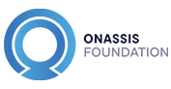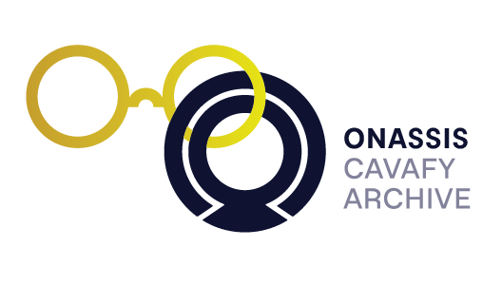

OPEN CALL
International Cavafy Summer School 2018
Cavafy and Antiquity

Onassis Library, Athens, 9 -15 July 2018
Application deadline: Wednesday 31 January 2018

The International Cavafy Summer School is a major international annual scholarly event organised by the Cavafy Archive and the Onassis Foundation, the first such regular event to be devoted exclusively to Cavafy and the impact of his work.

Following the inaugural Summer School that took place in July 2017, on the theme of Cavafy in the World, this year’s summer school will focus on Cavafy and Antiquity, a theme that shares many points of connection with the first summer school and its global concerns. The International Cavafy Summer School 2018 will be convened by Constanze Güthenke and Dimitris Papanikolaou (both at the University of Oxford). Tutors and presenters will include Johanna Hanink (Brown University), Brooke Holmes (Princeton University), Stefano Evangelista (University of Oxford), Alastair Blanshard (University of Queensland), Takis Kayalis (University of Ioannina) and Christodoulos Panayiotou (artist).

A selected group of 12 junior scholars will have a unique opportunity to attend world-class talks and to showcase new research. Doctoral students, postdoctoral researchers and early-career academics whose work relates to the fields of Comparative Literature, World Literature, Gender Studies, Cavafy Studies, Greek Studies and related areas, and who would like to take part in the International Cavafy Summer School are encouraged to apply by Wednesday 31 January 2018.

More information about the structure and aims of the school, as well as application requirements and students’ grants can be found in the following link:
http://www.onassis.org/en/cavafy-archive-education.php?id=163

Please address all relevant material and any inquiries to: Theodoros Chiotis and Marianna Christofi at cavafyarchive@onassis.org.

